**Name: Kanak Agrawal**

**DAY – 4 ASSIGNMENTS**

**Question:** Filtering Data: IN, DISTINCT, AND, OR, NOT, BETWEEN, LIKE, Column & table aliases.

**Answer:**

* **AND**

**Query:** select * from employee

where state ='Delhi' And country='India';

**Output:**

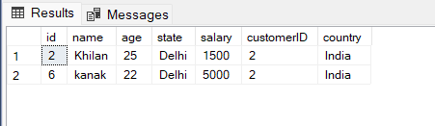

* **IN**

**Query:** select * from employee

where state in ('Delhi','Bhopal');

**Output:**

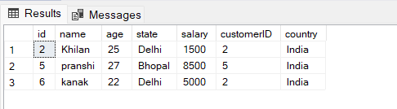

* **NOT**

**Query:** select * from employee

where state not like 'D%';

**Output:**

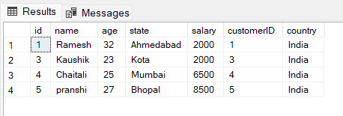

* **OR**

**Query:** select * from employee

where state ='Delhi' or country='India';

**Output:**

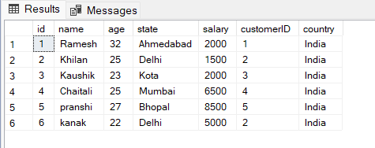

* **LIKE  
  Query:** select * from employee

where state like 'K%';

**Output:**

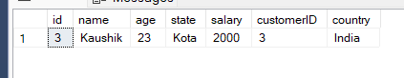

* **BETWEEN**

**Query:** select * from employee

where id between 1 and 5;

**Output:**

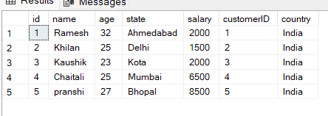

* **DISTINCT**

**Query:** select distinct name from employee;

**Output:**

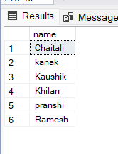

**Questions:** Total Aggregations using SQL Queries

* **MIN**

**Query:** select min(price)

from product;

**Output**:

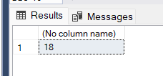

* **MAX**

**Query:** select max(price)

from product;

**Output:**

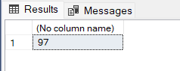

* **COUNT**

**Query:** select count(*)

from product;

**Output:**

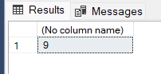

* **SUM**

**Query:** select sum(quantity)

from orderDetails;

**Output:**

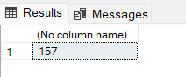

* **AVG**

**Query:** select avg(price)

from product;

**Output:**

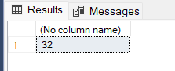

**Question:** Group By Aggregations using SQL Queries

**Answer:**

**Query:** select count (customerID),country

from employee

group by country

order by count(customerID)desc;

**Output:**

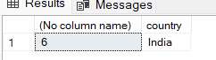

**Question:** Order of Execution of SQL Queries

**Answer:** The order of query execution in SQL is the order in which the various clauses in a SQL statement are executed. Generally, the order is as follows:

1. FROM clause
2. WHERE clause
3. GROUP BY clause
4. HAVING clause
5. SELECT clause
6. ORDER BY clause
7. **FROM**

**Query:** select * from employee

**Output:**

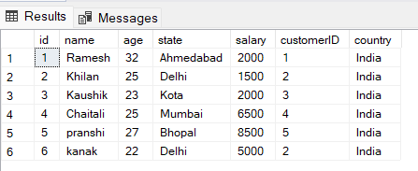

1. **WHERE**

**Query:** select * from employee

where id<10;

**Output:**

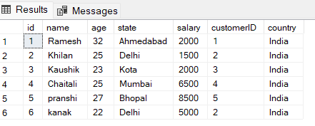

1. **GROUP BY   
   Query:** select count (customerID),country

from employee

group by country

**Output:**

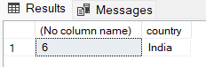

1. **HAVING**

**Query:** select customerID,sum(salary)

from employee

group by customerID

having sum(salary)>1000;

**Output:**

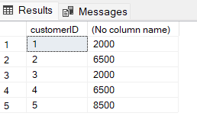

1. **SELECT**

**Query:** select * from employee

**Output:**

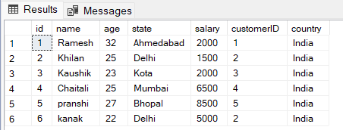

1. **ORDER BY**

**Query:** select * from product

order by price desc;

**Output:**

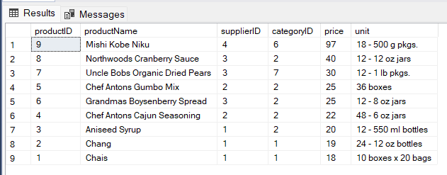

**Questions:**

* **EQUI JOIN**

**Query:** select product.productName,product.productID,orderDetails.orderID,

orderDetails.quantity

from product

join orderDetails

on product.productID=orderDetails.productID;

**Output:**

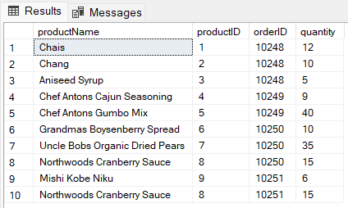

* **NON EQUI JOIN**

**Query:** selectproduct.productName,orderDetails.orderDetaillsID,

orderDetails.quantity

from product,orderDetails

where product.productID < orderDetails.orderDetaillsID;

**Output:**

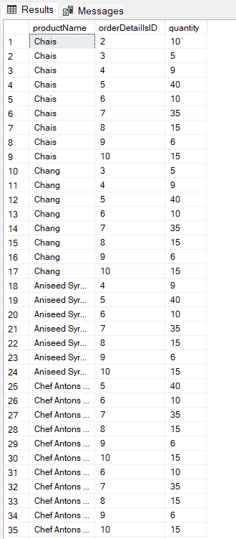

**Question:** Querying Data by Using Subqueries

**Answer:**

**Query:** SELECT productName

FROM Product

WHERE ProductID = ANY

(SELECT ProductID

FROM OrderDetails

WHERE Quantity = 10)

**Output:**

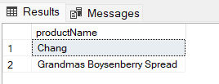

**Questions:** Using the EXISTS, ANY, ALL Keywords

Answer:

* **EXISTS**

**Query:** SELECT SupplierName

FROM Supplier

WHERE EXISTS (SELECT ProductName FROM Product WHERE Product.SupplierID = Supplier.supplierID AND Price <= 30);

**Output:**

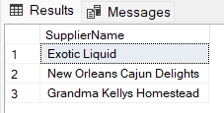

* **ANY**

**Query:** SELECT productName

FROM Product

WHERE ProductID = ANY

(SELECT ProductID

FROM OrderDetails

WHERE Quantity = 10)

**Output:**

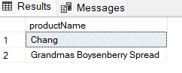

* **ALL**

**Query:** SELECT ProductName

FROM Product

WHERE ProductID = ALL

(SELECT ProductID

FROM OrderDetails

WHERE Quantity = 1);

**Output:**

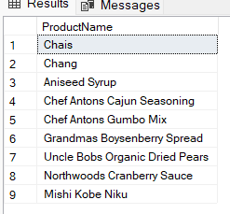

**Question:** String Function

**Answer:**

* **REVERSE**

**Query:** select REVERSE('Kanak Agrawal');

**Output:**

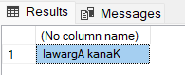

* **LOWER**

**Query:** select LOWER('Kanak Agrawal');

**Output:**

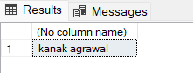

* **UPPER**

**Query:** select upper('Kanak Agrawal');

**Output:**

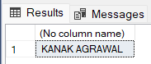

* **CONCAT**

**Query:** select CONCAT ('Kanak Agrawal','@gmail.com');

**Output:**

